**INSPIRATIONBASE**

*A collection of ethical leadership speeches*

Oprah Winfrey

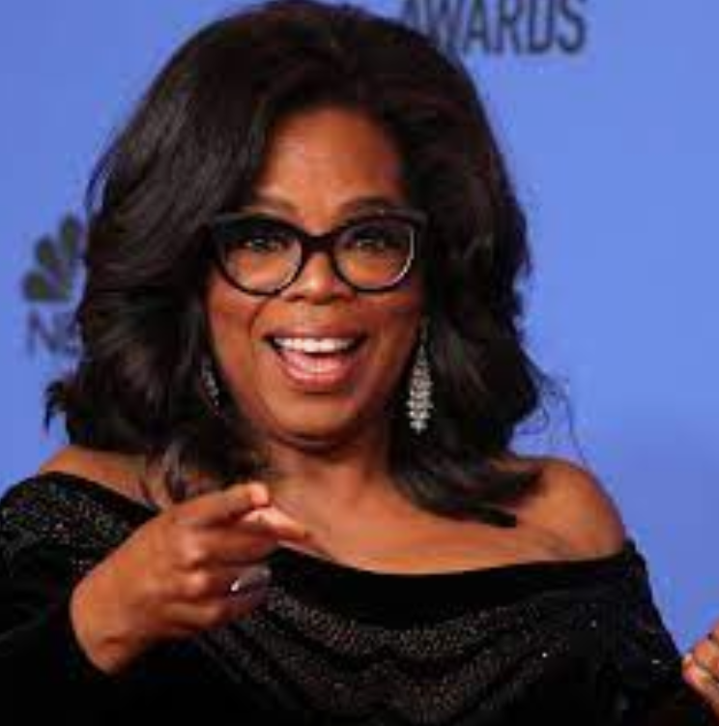

Oprah Winfrey is an American television personality, actress, and entrepreneur whose syndicated daily talk show, The Oprah Winfrey Show, was among the most popular of the genre…Winfrey engaged in numerous philanthropic activities, including the creation of Oprah’s Angel Network, which sponsors charitable initiatives worldwide…. She won the Cecil B. DeMille Award (a Golden Globe for lifetime achievement) in 2018, and her impassioned speech—in which she called for racial and gender equality—was widely seen as one of the ceremony’s most memorable moments. Source: Britannica ([link](https://www.britannica.com/biography/Oprah-Winfrey))

|  |  |  |  |  |
| --- | --- | --- | --- | --- |
| **OW 1*. Commencement Speech to the Class of 2020: "What Will Your Essential Service Be?"*** | | | |  |
| I know you may not feel like it, but you are indeed the chosen class, for such a time as this…the class of 2020. You are also a united class—the pandemic class that has the entire world striving to graduate with you. Of course, this is not the graduation ceremony you envisioned: You’ve been dreaming about the walk across the stage, your family and friends cheering you on, the caps flung joyously in the air. But even though there may not be pomp because of our circumstances, never has a graduating class been called to step into the future with more purpose, vision, passion and energy, and hope.  …So can you use this disorder that COVID-19 has wrought? Can you treat it as an uninvited guest that’s come into our midst to re-order our way of being? Can you, the class of 2020, show us not how to put the pieces back together again, but how to create a new and more evolved normal, a world more just, kind, beautiful, tender, luminous, creative, whole?  We need you to do this because the pandemic has illuminated the vast systemic inequities that have defined life for too many for too long. For poor communities without adequate access to healthcare, inequality is a pre-existing condition. For immigrant communities forced to hide in the shadows, inequality is a pre-existing condition. For incarcerated people with no ability to social-distance, inequality is a pre-existing condition. For every person burdened by bias and bigotry, for every black man and woman living in their American skin, fearful to even go for a jog, inequality is a pre-existing condition. You have the power to stand for, to fight for—and vote for—healthier conditions that will create a healthier society. This moment is your invitation to use your education to begin to heal our afflictions, by applying the best of what you’ve learned in your head and felt in your heart.  This moment has shown us what Dr. King tried to tell us. Decades ago he understood that “we are caught in an inescapable network of mutuality, tied into a single garment of destiny.” That’s what he said. “Whatever affects one directly, affects all indirectly.” If humanity is a global body, every soul is a cell in that body. And we are being challenged as never before to keep the global body healthy by keeping ourselves healthy in mind, body and spirit. As all the traditions affirm, the deepest self care is at once caring for the human family.  We see this so clearly with essential workers. Look who turns out to be essential! Teachers—your teachers!—healthcare workers of course, the people stocking grocery shelves, the cashiers, the truck drivers, food providers, those who are caring for your grandparents, those who clean the places where we work and shop and carry out our daily lives. We are all here because they, at great and profound risk, are still providing their essential service.  What will your essential service be?  What really matters to you? The fact that you’re alive means you’ve been given a reprieve to think deeply about that question. How will you use what matters in service to yourself, your community, and the world? For me it has always been talking and sharing stories. For you—well, that’s for you to discover.  My hope is that you will harness your education, your creativity, your valor, your voice, your vote—reflecting on all that you’ve witnessed and hungered for, all that you know to be true—and use it to create more equity, more justice, and more joy in the world. | | | | |
| **Date** | 15/05/20 | **Source** | The Oprah Magazine ([link](https://www.oprahmag.com/life/a32492831/oprah-commencement-speech-2020-full-transcript/)) | |

|  |  |  |  |  |
| --- | --- | --- | --- | --- |
| **OW 2: Golden Globe Speech** | | | |  |
| In 1964, I was a little girl sitting on the linoleum floor of my mother's house in Milwaukee watching Anne Bancroft present the Oscar for best actor at the 36th Academy Awards. She opened the envelope and said five words that literally made history: "The winner is Sidney Poitier." Up to the stage came the most elegant man I had ever seen. I remember his tie was white, and of course his skin was black, and I had never seen a black man being celebrated like that. I tried many, many times to explain what a moment like that means to a little girl, a kid watching from the cheap seats as my mom came through the door bone tired from cleaning other people's houses…  In 1982, Sidney received the Cecil B. DeMille award right here at the Golden Globes and it is not lost on me that at this moment, there are some little girls watching as I become the first black woman to be given this same award. …  I want to thank the Hollywood Foreign Press Association because we all know the press is under siege these days. We also know it's the insatiable dedication to uncovering the absolute truth that keeps us from turning a blind eye to corruption and to injustice. To -- to tyrants and victims, and secrets and lies. I want to say that I value the press more than ever before as we try to navigate these complicated times, which brings me to this: what I know for sure is that speaking your truth is the most powerful tool we all have. And I'm especially proud and inspired by all the women who have felt strong enough and empowered enough to speak up and share their personal stories. Each of us in this room are celebrated because of the stories that we tell, and this year we became the story.  But it's not just a story affecting the entertainment industry. It's one that transcends any culture, geography, race, religion, politics, or workplace. So I want tonight to express gratitude to all the women who have endured years of abuse and assault because they, like my mother, had children to feed and bills to pay and dreams to pursue. They're the women whose names we'll never know. They are domestic workers and farm workers. They are working in factories and they work in restaurants and they're in academia, engineering, medicine, and science. They're part of the world of tech and politics and business. They're our athletes in the Olympics and they're our soldiers in the military.  And there's someone else, Recy Taylor, a name I know and I think you should know, too. In 1944, Recy Taylor was a young wife and mother walking home from a church service she'd attended in Abbeville, Alabama, when she was abducted by six armed white men, raped, and left blindfolded by the side of the road coming home from church. They threatened to kill her if she ever told anyone, but her story was reported to the NAACP where a young worker by the name of Rosa Parks became the lead investigator on her case and together they sought justice. But justice wasn't an option in the era of Jim Crow. The men who tried to destroy her were never persecuted. Recy Taylor died ten days ago, just shy of her 98th birthday. She lived as we all have lived, too many years in a culture broken by brutally powerful men. For too long, women have not been heard or believed if they dare speak the truth to the power of those men. But their time is up. Their time is up.  Their time is up. And I just hope -- I just hope that Recy Taylor died knowing that her truth, like the truth of so many other women who were tormented in those years, and even now tormented, goes marching on. It was somewhere in Rosa Parks' heart almost 11 years later, when she made the decision to stay seated on that bus in Montgomery, and it's here with every woman who chooses to say, "Me too." And every man -- every man who chooses to listen.  In my career, what I've always tried my best to do, whether on television or through film, is to say something about how men and women really behave. To say how we experience shame, how we love and how we rage, how we fail, how we retreat, persevere and how we overcome. I've interviewed and portrayed people who've withstood some of the ugliest things life can throw at you, but the one quality all of them seem to share is an ability to maintain hope for a brighter morning, even during our darkest nights. So I want all the girls watching here, now, to know that a new day is on the horizon! And when that new day finally dawns, it will be because of a lot of magnificent women, many of whom are right here in this room tonight, and some pretty phenomenal men, fighting hard to make sure that they become the leaders who take us to the time when nobody ever has to say "Me too" again. | | | | |
| **Date** | 10/1/2018 | **Source** | CNN ([link](https://edition.cnn.com/2018/01/08/entertainment/oprah-globes-speech-transcript/index.html)) | |