INSPIRATIONBASE
A collection of ethical leadership speeches
Others

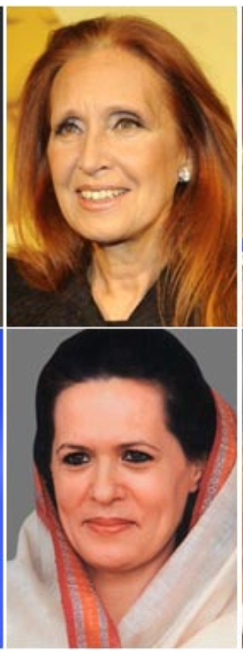
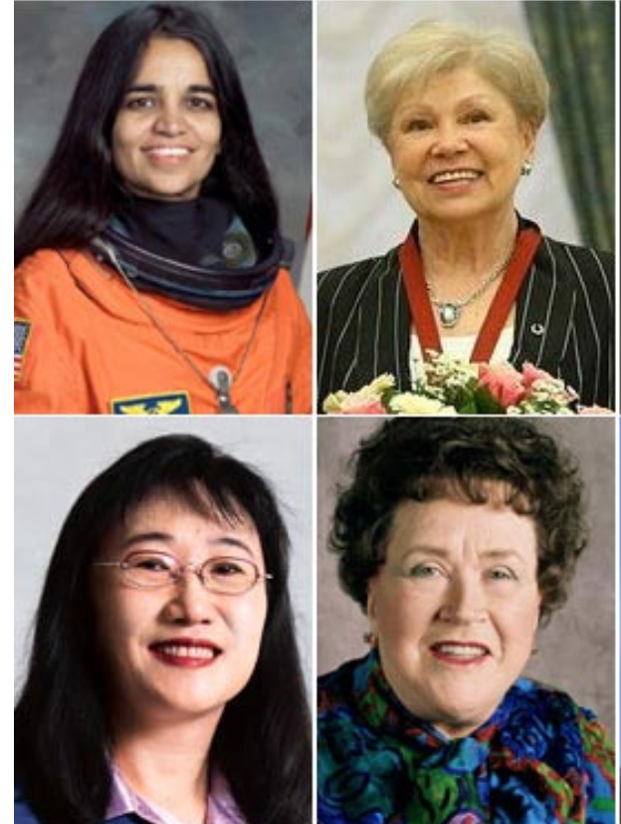

This document contains suggestions from members of the International Ecolinguistics Association for inspirational speeches which have not yet been formatted into seperate Inspirationbase documents.

Djaffar Shalchi: The American dream is now in Denmark
Right now, philanthropy is treated as an alternative to structural change. I focus on structural change, and I am working to persuade other multimillionaires to join me, advocating for a wealth tax on people like us. I still do philanthropy, but I know that it is no solution. You know, the thrill of seeing your nameplate on one school or a hundred schools is pretty empty in the end, compared to the thrill that we will all feel when every child in the world goes to a good school. Philanthropy is just so unambitious.

Full transcript: https://the.ink/p/the-american-dream-is-now-in-denmark

Gina Lopez: Speech of DENR Secretary Gina Lopez at COP22, Marrakech, Morocco
"There is an integratedness of life. Yesterday, I was in awe at dynamism and non-negotiable commitment of the leaders of the Climate Change movement. If we all imbibe this consciousness deep in our hearts and manifest it in ground level reality - humanity faces a bright future if we continue to bloom this spirit of working together. The Philippines is making a commitment to this exciting future." Full transcript at https://bit.ly/2P4CUvt

Gina Lopez (1953-2019) was a Filipino environmentalist and philanthropist who served as Secretary of the Philippines' Department of Environment and Natural Resources (DENR) in an ad interim basis under President Rodrigo Duterte. She was previously the Chairperson of the Pasig River Rehabilitation Commission under two consecutive administrations.

Amanda Gorman: The Hill We Climb
So while once we asked, ‘How could we possibly prevail over catastrophe?’ now we assert, ‘How could catastrophe possibly prevail over us?’

We will not march back to what was, but move to what shall be:
A country that is bruised but whole, benevolent but bold, fierce and free.
We will not be turned around or interrupted by intimidation because we know our inaction and inertia will be the inheritance of the next generation.
Our blunders become their burdens.
But one thing is certain:
If we merge mercy with might, and might with right, then love becomes our legacy and change, our children’s birthright.

https://www.theguardian.com/us-news/2021/jan/20/amanda-gorman-poem-biden-inauguration-transcript

Plus: ‘Unity With Purpose.’ Amanda Gorman and Michelle Obama Discuss Art, Identity and Optimism
https://time.com/5933596/amanda-gorman-michelle-obama-interview/

Imran Khan, Prime Minister of Pakistan
1. Speech at the UNGA

First let me talk about climate change; I have seen a lot of leaders talk about this. But I don’t see world leaders really realizing the urgency of the situation. We have a lot of ideas; but as they say, ideas without funding is mere hallucination.

Pakistan is among the top 10 nations in the world affected by climate change. We depend on or rivers, we are mainly an agricultural country. 80 percent of our water comes from the glaciers and these are melting at an alarming pace.

We detected 5000 glacier lakes in our mountains. If nothing is done, we fear humans are facing a huge catastrophe.

In KP, a province of Pakistan, we planted a billion trees in 5 years. Now we are targeting 10 billion trees. But one country can not do anything. This has to be a combined effort of the world.

My optimism comes from the fact that the Almighty has given humans great powers. We can do great things. And this is where I want the United Nations to take the lead in invoking this will.

Rich countries who contribute the most to green house gas emissions must be held accountable.

Mr. President; every year billions of dollars leave poor countries & go to rich countries. Billions of dollars siphoned by corrupt politicians to tax havens,expensive properties bought in western capitals. It is devastating to the developing world.

Corruption is impoverishing the developing world. Difference b/w rich & poor countries is growing due to this. Money laundering is not treated the same as drug money or terror financing. Today poor countries are being plundered by their elites.

In my country, when I took charge of our government a year back, in the 10 years preceding that our total debt went up 4 times. As a result; the total revenue we collect in one year, half of it went into debt servicing.

How will we spend on our 220 million population when our money was plundered by the ruling elite? And when we located properties of these corrupt leaders in western capitals, we find it so difficult to retrieve it.

If we retrieve the plundered money, we could spend it on human development. But there are laws protecting these criminals. We don’t have the money to hire lawyers worth millions of dollars.

The rich countries must show political will; they can not allow this flight of capital from poor countries through corruption. How can poor countries meet the United Nations SDG’s when money for human development can easily leave our countries?

There must be a deterrent; the corrupt ruling elite must not be allowed to take money out and park it in tax havens. Why is it legal to have tax havens where you have these secret accounts?

The world is changing; if the poor get poorer and the rich get richer, there will be a crisis soon. It will lead to a major crisis. The world bank, the IMF, the Asian developing bank must find a way to stop this plunder.

Source: https://www.brecorder.com/news/524851

2. Address at General Assembly Seventy-fourth session, 9th plenary meeting

“I especially came to this forum despite a difficult time in my country; facing challenges... I would not have come had there not been a very urgent problem that the world must address.
First let me talk about climate change; I have seen a lot of leaders talk about this. But I don’t see world leaders really realizing the urgency of the situation. We have a lot of ideas; but as they say, ideas without funding is mere hallucination.
Pakistan is among the top 10 nations in the world affected by climate change. We depend on or rivers, we are mainly an agricultural country. 80 percent of our water comes from the glaciers and these are melting at an alarming pace.
We detected 5000 glacier lakes in our mountains. If nothing is done, we fear humans are facing a huge catastrophe.
In KP, a province of Pakistan, we planted a billion trees in 5 years. Now we are targeting 10 billion trees. But one country can not do anything. This has to be a combined effort of the world.
My optimism comes from the fact that the Almighty has given humans great powers. We can do great things. And this is where I want the United Nations to take the lead in invoking this will.
Rich countries who contribute the most to green house gas emissions must be held accountable.

Source: https://www.brecorder.com/news/524851

3. Speech at World Economic Forum's Country Strategic Dialogue on Pakistan 2020.

Climate change is one of the defining global challenges faced by our generation. It has far-reaching adverse economic, social and political impacts. The world is already witnessing unprecedented floods, severe droughts, increasing heat waves, spreading wildfires and fierce cyclonic activity. All of these pose a clear and present danger for humanity. While no country is immune from these impacts of climate change, most developing countries remain disproportionately affected by its negative impacts.
Pakistan is a case in point, as it lies at the geographic crossroads of melting glaciers, unpredictably shifting monsoons and enhanced disaster activity triggered by climate change. Despite Pakistan’s diminutive contribution to global green house gas emissions, we are the fifth most climate-impacted country in the world, as indicated by the Germanwatch Global Climate Risk Index, 2020.
There is an urgent need for simultaneously raising ambition for climate action, while also building resilience and adapting to the inescapable impacts of climate change. Climate action by the developing countries, however, has to be based on the established principles of Equity and Common but Differentiated Responsibilities and Respective Capabilities (CBDR–RC) - as agreed under the United Nations Framework Convention on Climate Change (UNFCCC) and its Paris Agreement. It is also vital that developing countries are supported with enhanced climate finance, appropriate technology transfer and supportive capacity-building. In this regard, the existing pledge by the developed countries to mobilize $100 billion annually in climate finance for the developing countries remains critically essential, but as yet unfulfilled.
On its part, my government remains fully committed to play a leadership role in addressing the issue of climate change and making a shift towards a “clean and green” Pakistan through a well-articulated climate change agenda consisting of a number of on-the-ground flagship initiatives. Subsequent to the successful achievement of planting a billion trees in Khyber Pakhtunkhwa province of Pakistan (2014-18), which enhanced the provincial forest cover by 6%, we are now implementing the “10 Billion Trees Tsunami” initiative which will restore and enhance over 1 million hectares of forest across the country. This project is expected to deliver multiple dividends by creating green jobs, sequestering carbon as well as promoting ecosystem-based adaptation. A truly win-win nature based solution.
In addition, the “Protected Areas Initiative”, launched during the COVID-19 era, is enhancing our national coverage of protected areas from 12% to 15% of land area while preserving Pakistan’s unique and valuable biodiversity and has already increased our number of National Parks from 30 to 45 in just one year. All of these are also creating nature jobs while creating opportunities for eco-tourism and climate change adaptation at the same time.
On the energy side, Pakistan remains committed to realizing the untapped renewable energy potential – in hydro, solar and wind – and to shift our energy mix to 60% clean energy by 2030. This clean energy transition is complemented by the enactment of our first Electric Vehicle policy (2020), which targets 30% of our vehicles to go electric by 2030. Furthermore, the world’s first “zero emissions” metro line project designed to turn cattle dung into methane to power buses, has already been approved for the city of Karachi. Recently, we also shifted our transport fuel quality from Euro-2 to the much cleaner Euro-V standard in one big leap. All these initiatives speak to our unrelenting commitment to eco-friendly, sustainable and climate-compatible development
On climate adaptation, Pakistan remains a vulnerable country without a choice. Our climate adaptation needs range from $7 billion to $14 billion per annum, as we are compelled to undertake adaptation measures in response to climate triggered disasters. Amid this adversity, we have realized the value of investing in nature-based solutions. One such solution is the eco-system-based “Recharge Pakistan” initiative, which aims to effectively manage and prudently utilize our water resources – turning catastrophic floods into an opportunity for recharging aquifers and naturally restoring ecosystems. This project, when fully implemented, will positively impact around 10 million vulnerable people, through reduced risk from floods and enhanced livelihoods by the year 2030.
The ongoing COVID-19 pandemic is inflicting unparalleled human suffering and has triggered the worst recession since the 1930s Great Depression. The developing countries have been hit the hardest and their contracting economies have posed a serious threat to their quest for raising ambition for climate action. Even in these challenging times, Pakistan carved out a silver lining through “Green Stimulus”, aimed at nature protection and creation of green jobs. During the pandemic lockdowns we have created around 85,000 COVID safe green jobs – planting trees, protecting nature and improving sanitation – which are planned to be scaled-up to 200,000 by December 2020. This Green Stimulus is helping Pakistan to build back green and focus on a nature positive recovery.
Pakistan is also actively pursuing innovative global financing for its ambitious climate agenda, through structuring “Debt for Nature” swaps or “Nature Bonds” based on the credible ongoing activities outlined above and the renegotiation of Pakistan’s burgeoning debt with countries supportive of a green revival of the global economy.
Climate change is undoubtedly the most threatening issue of our time and an issue without a vaccine. There is no short-cut solution to enhanced, cooperative and coordinated global climate action. Pakistan stands ready and committed to not only play its role in furthering global efforts to combat this menace but also lead the way with real on-the-ground solutions.
Source: https://www.weforum.org/agenda/2020/11/leading-by-doing-pakistani-pm-imran-khan-on-climate-change/

Mario Draghi: Le dichiarazioni programmatiche del Presidente Draghi (in Italian)
Le comunicazioni del Presidente del Consiglio, Mario Draghi, al Senato della Repubblica sulle dichiarazioni programmatiche del Governo.

Full transcript available here:

http://www.governo.it/it/articolo/le-comunicazioni-del-presidente-draghi-al-senato/16225

Eduardo Galeano: Valores emergentes (in Spanish)
(with thanks to Alejandra Lucía for transcription)
https://www.youtube.com/watch?v=uEa3yKaICFs

"Lo más importante de este proceso que se está dando, y es verdad que se está dando en muchos lugares, de emergencia, algo así como una especie de resurrección de las luchas indígenas que parecían sepultadas o condenadas a sonar en campana de barro, y ahora tienen bastante resonancia, no? Eso... lo más importante para mí es que ponen en evidencia la porfiada capacidad de supervivencia que tienen algunos valores. Eso es impresionante. Han pasado más de cinco siglos de persecución y de desprecio y sin embargo algunos de los valores que regían la vida de las culturas americanas anteriores a la conquista ahora están resucitando con enorme fuerza, con muchísima energía. Es como si hubiera en la historia humana, la nuestra, músculos... Uno dice pero cómo es posible que eso siga vivo, cómo es posible que esas palabras rotas, esas palabras traicionadas, esas palabras mentidas, estranguladas, puedan ahora volver a resonar, y resonar con tanta intensidad, cómo se puede explicar, los mensajes que vienen del pasado y hablan al futuro. La vida en comunidad, no centrada en la codicia sino en la solidaridad. La comunión con la naturaleza, por la cual comunión con la naturaleza tantos indígenas fueron azotados, o quemados, ardieron en el fuego por delito de herejía, de idolatría... Y esa comunión con la naturaleza, que es una cosa que tendríamos que aprender todos, hoy por hoy, y sobre todo los que tenemos... yo mismo, verdad, que me siento muy ecologista, muy vinculado a los movimientos ecologistas en el mundo actual. Pero bueno, mucho cuidado con confundir a la naturaleza con un jardín o con una tarjeta postal. Lo que nos enseñana aquellas culturas llamadas primitivas es que nosotros somos parte de ella, somos parte de la naturaleza, y es por eso que cualquier crimen contra ella cometido nos lastima y nos puede matar, porque somos hermanos de todo lo que tiene piernas, pero también de todo lo que tiene patas, alas, raíces. Esta certeza de identidad con la naturaleza que la cultura cristiana o llamada cristiana rompió en América. Una discontinuidad de eso, ahí se fracturó. Empezamos a mirar a la naturaleza como algo extraño, y durante mucho tiempo como algo enemigo, como una especie de bestia indomable a la que era necesario amansar. Entonces ese es uno de los valores más importantes que ahora resultan rescatados por la historia y que vuelven a vivir con una fuerza realmente impresionante. También algunas de las formas de expresión democrática que existían en la América antigua y que hoy por hoy siguen vivas en algunas de las comunidades indígenas, cosas que creo que son importantes, no es solamente la reivindicación, muy legítima, de las tierras usurpadas, de la dignidad mancillada, malherida, escupida, no es sólo eso. Es también la reivindicación de valores que son valores para todos. Entonces cuidado, vamos a tratar de escuchar esas voces poco escuchadas, o jamás escuchadas, porque tienen cosas que decirnos que valen la pena, y valen la pena hoy por hoy más que nunca, porque el mundo anda ahí como un ciego en tiroteo, buscando rumbo sin saber para dónde ir."

Miscellaneous
Collection of speeches in book form: Speaking of Earth: Environmental Speeches that Moved the World
Erica Violet Lee at The Peoples Climate Week https://www.youtube.com/watch?v=tE6fwplfQkI
Prince EA: https://www.youtube.com/user/thamagicsho2003
Tom Foolery: the great realisation: https://www.youtube.com/watch?v=Nw5KQMXDiM4&t=23s
Michael Pollen’s Omnivore’s Dilemma: https://www.youtube.com/watch?v=kFpjskn3_Pc
Dalai Lama on global warming: https://www.youtube.com/watch?v=GcZnSAlziek&t=3s&ab_channel=DalaiLama

Passion animale et végétale: A Message from Nature to Man
Message from Nature to Man

We are insects. We are 10 million species across the planet. We have an essential role for the whole ecosystem for many of you. We are frightened and you are afraid of us. For your information, we are here to worry nobody. Without us, there are no flowers, no fruits, no vegetables.

We are essential to life, We fertilize. We recycle. We react. We pollinate. For the majority of use, we represent danger even if we are sometimes impressing you out of fear, because you are colossal, you are gigantic. So to defend ourselves we may sometimes attack you and you also do the same thing to protect others. We live in fear. We share territories with all the species. We form a whole ecosystem.

As for life today, the planet is so beautiful. That is because we have our share of responsibility. You, Human Beings! You do nothing except destruction. You Do not respect us with all our kinds of products. You confiscate lands to eradicate us. You are enticed to make these lands infertile. For us, life is not easy. We know that we are also the prey of birds and mammals. It is with this sacrifice that life exists through extinction. Other species, apart from us, are also extincting: birds, mammals, plants.

One day, you, Human Beings, will disappear. What is happening to you? Are you entirely blinded? All creatures are like us. You come from nature; it is the one that has created you. You have been babies for thousands of epochs. You have loved it; it feeds you, protects you! It is a hand of help.

Have you forgotten your mother nature? Are you really disconnected from it? Why? Who obeys his mother? You keep destroying your environment and polluting it as much as you can; the air you breathe. You are not only just causing destruction among our elements, but also among other species.

Human beings! You gave up maintaining your environment and everything around you. What is happening nowadays is that you destroy everything around you tirelessly. We, the insects, are here to serve you and the whole planet equally. You react as if you are the owner of this planet.And since you are but a simple tenant of this planet, the planet needs you. You need this planet , other species and us, the insects.

More than 70% of our species is extinct.

Nevertheless, we are of major importance for the balance of this planet and life.

Please, stop destroying us, because you are destroying yourselves ! Rescue us!

Translated from French by Tamer Osman

More coming soon…

