**INSPIRATIONBASE**

*A collection of ethical leadership speeches*

John Lewis

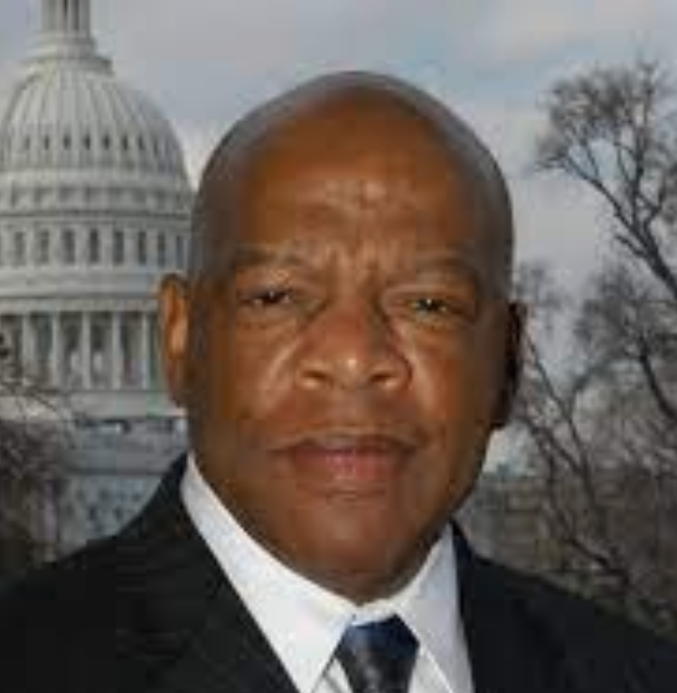

John Lewis (1940-2020), American civil rights leader and politician best known for his chairmanship of the Student Nonviolent Coordinating Committee (SNCC) and for leading the march that was halted by police violence on the Edmund Pettus Bridge in Selma, Alabama, in 1965, a landmark event in the history of the civil rights movement that became known as “Bloody Sunday.” Source: Britannica ([link](https://www.britannica.com/biography/John-Lewis-American-civil-rights-leader-and-politician)).

|  |  |  |  |  |
| --- | --- | --- | --- | --- |
| **JL 1*. Caltech Commencement Speech*** | | | |  |
| Today is a good day. A great day. Tomorrow you will step into the world, roll up your sleeves, and put your talent and education to work. You know time flies by so quickly. You must make the most of every moment. […] You must use every minute, every hour, and every day to make your mark on this world. To make it a little more peaceful, a little cleaner, and a little greener for generations yet unborn. I remember when I was in your shoes and it feels like just yesterday and I got in trouble, good trouble, by following the teaching of Dr. Martin Luther King Jr. He taught me to stand up, to speak up, to speak out, and to get in the way, to get in trouble. […] For many of us Dr. Martin Luther King Jr. was a breath of fresh air. His strength and his dignity inspired us. His message of peace, love, and non-violence helped us find a way to get in the way. His faith and his teaching moved a generation to act. This one young man - he was so young, so gifted - he sparked a non-violent revolution. A revolution of values, a revolution of ideas, a revolution of action. Not just in America but around the world. And because of his action, his leadership, we are much better off as a nation and as a people and as a world community. Sixty years ago, Dr. Martin Luther King Jr. brought the revolution to this great institution. I am so pleased to see how the seeds that he planted to root blossomed and continue to grow to this very day. At Caltech you open your minds, your arms, your hearts, and your souls to those who have been left out and left behind. You offer a kind word and a helping hand to those who feel forgotten and alone. And I wanna take just one moment to thank each and every one of you for marching for science. We need science now more than ever before. I wanna thank all of your teachers, your administrators, members of the board of trustees, your beloved president, your parents, your friends. But you must continue to speak up, and speak out for what is right and what is just. Whether it be the dignity of the dreamers, the injustice of a tax bill, or the importance of science - you can make a way out of no way. Dr. King uses that from time to time: that we have learned to fly in the air like a bird. We have learned to swim in an ocean like a fish. But we have not yet learned how to walk on this planet and live together like humans. You have to change that. You must be committed to building the beloved community and making this world a little cleaner and greener for generations yet unborn, as I said. As I look back, I will tell you that as a nation and as the people we have made progress. The signs may be gone, but there are forces in America today trying to take us back, and take us to another place. We have come too far, we made too much progress, and we are not going back. We are going forward because of you young minds and your leadership. You must help fight for the soul, not just for our nation but for the soul of the planet. There’s too many people been left out and left behind. People suffering, not just in America but around the world. We must be brave. We must be courageous. We must be bold. If Dr. King were with us today, he would continue to push our country to respect the dignity and the worth of every human being. No matter where they are born, no matter their race, age, religion, and gender. So I appeal to each and every one of you, as you leave this wonderful place for learning, that you find a way to get in the way. […] I say to each and every one of you: continue to stand up, speak up, and speak out. Continue to be brave and bold and courageous. And all of us can play a role in saving our democracy. We have to save it. Here at home and wherever it exists abroad. That is your calling. That is your mission. I know each and every one of you are committed to science. To technology. I urge you also to study the way of peace. Study the way of love. Study the philosophy of non-violence, the teaching of Ghandi and Thoreau. And help humanize that little planet, that little spaceship we call Earth. | | | | |
| **Date** | 15/06/2018 | **Source** | Caltech, YouTube ([link](https://www.youtube.com/watch?v=vgkA49SeR_k)) | |

|  |  |  |  |  |
| --- | --- | --- | --- | --- |
| **JL 2*. Together you can redeem the soul of our nation*** | | | |  |
| *John Lewis died on July 17, 2020 but wrote these words shortly before his death.*  While my time here has now come to an end, I want you to know that in the last days and hours of my life you inspired me. You filled me with hope about the next chapter of the great American story when you used your power to make a difference in our society. Millions of people motivated simply by human compassion laid down the burdens of division. Around the country and the world you set aside race, class, age, language and nationality to demand respect for human dignity.  That is why I had to visit Black Lives Matter Plaza in Washington, though I was admitted to the hospital the following day. I just had to see and feel it for myself that, after many years of silent witness, the truth is still marching on.  Emmett Till was my George Floyd. He was my Rayshard Brooks, Sandra Bland and Breonna Taylor. He was 14 when he was killed, and I was only 15 years old at the time. I will never ever forget the moment when it became so clear that he could easily have been me. In those days, fear constrained us like an imaginary prison, and troubling thoughts of potential brutality committed for no understandable reason were the bars.  Though I was surrounded by two loving parents, plenty of brothers, sisters and cousins, their love could not protect me from the unholy oppression waiting just outside that family circle. Unchecked, unrestrained violence and government-sanctioned terror had the power to turn a simple stroll to the store for some Skittles or an innocent morning jog down a lonesome country road into a nightmare. If we are to survive as one unified nation, we must discover what so readily takes root in our hearts that could rob Mother Emanuel Church in South Carolina of her brightest and best, shoot unwitting concertgoers in Las Vegas and choke to death the hopes and dreams of a gifted violinist like Elijah McClain.  Like so many young people today, I was searching for a way out, or some might say a way in, and then I heard the voice of Dr. Martin Luther King Jr. on an old radio. He was talking about the philosophy and discipline of nonviolence. He said we are all complicit when we tolerate injustice. He said it is not enough to say it will get better by and by. He said each of us has a moral obligation to stand up, speak up and speak out. When you see something that is not right, you must say something. You must do something. Democracy is not a state. It is an act, and each generation must do its part to help build what we called the Beloved Community, a nation and world society at peace with itself.  Ordinary people with extraordinary vision can redeem the soul of America by getting in what I call good trouble, necessary trouble. Voting and participating in the democratic process are key. The vote is the most powerful nonviolent change agent you have in a democratic society. You must use it because it is not guaranteed. You can lose it.  You must also study and learn the lessons of history because humanity has been involved in this soul-wrenching, existential struggle for a very long time. People on every continent have stood in your shoes, through decades and centuries before you. The truth does not change, and that is why the answers worked out long ago can help you find solutions to the challenges of our time. Continue to build union between movements stretching across the globe because we must put away our willingness to profit from the exploitation of others.  Though I may not be here with you, I urge you to answer the highest calling of your heart and stand up for what you truly believe. In my life I have done all I can to demonstrate that the way of peace, the way of love and nonviolence is the more excellent way. Now it is your turn to let freedom ring.  When historians pick up their pens to write the story of the 21st century, let them say that it was your generation who laid down the heavy burdens of hate at last and that peace finally triumphed over violence, aggression and war. So I say to you, walk with the wind, brothers and sisters, and let the spirit of peace and the power of everlasting love be your guide. | | | | |
| **Date** | 30/07/2020 | **Source** | New York Times ([link](https://www.nytimes.com/2020/07/30/opinion/john-lewis-civil-rights-america.html)) | |