**INSPIRATIONBASE**

*A collection of ethical leadership speeches*

Severn Cullis-Suzuki

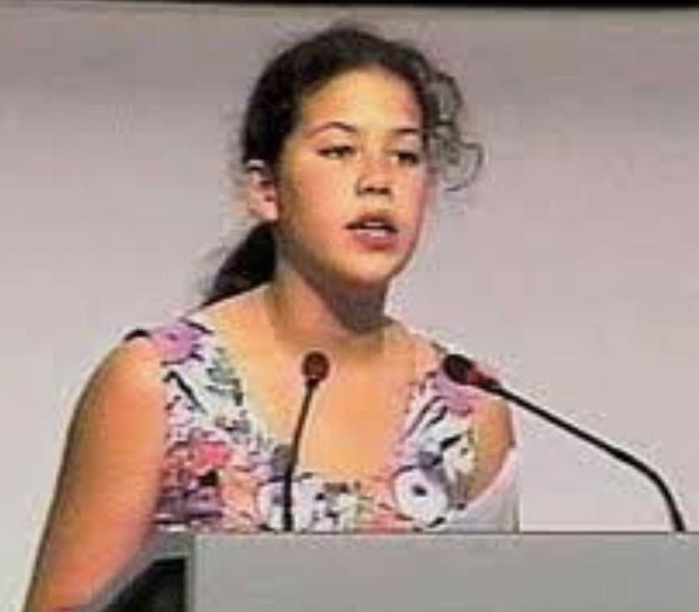

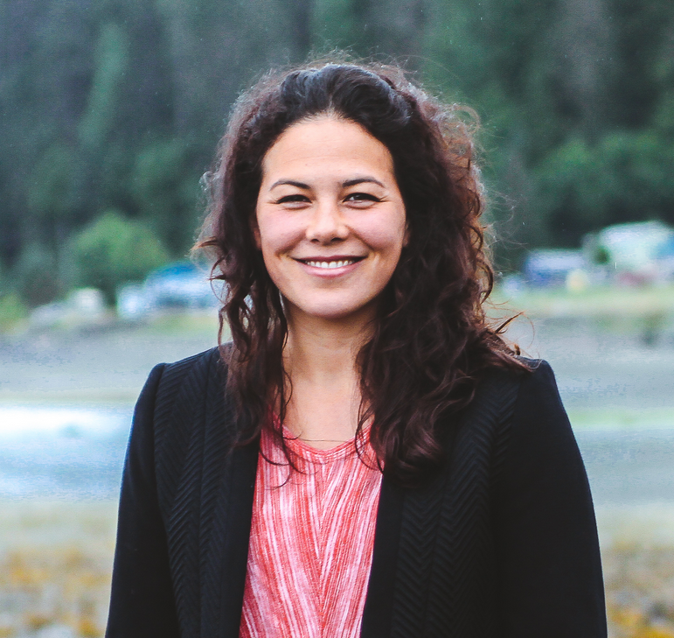Severn Cullis-Suzuki (Canada) is a culture and environment activist and write…host of the APTN TV series 'Samaqan – Water Stories’, and board member of the Haida Gwaii Higher Education Society and the David Suzuki Foundation. A longtime activist for ‘intergenerational justice’, Severn founded the Environmental Children’s Organization with friends at nine years old, which culminated in her speech to the UN at the Rio Earth Summit in 1992 when she was twelve…Severn has participated in three speaking tours in Japan with the Namakemono Club… has published several books in Japan, and is a co-editor and contributor for the book Notes from Canada’s Young Activists (Greystone books, 2007). She holds a B.Sc. in Biology from Yale University and a M.Sc. in Ethnoecology from the University of Victoria, where she studied with elders from the Kwakwaka’wakw First Nations. Severn lives on the archipelago of Haida Gwaii off the coast of British Columbia where she is studying the Haida language with her husband and two sons. Source: Earth Charter ([link](https://earthcharter.org/severn-cullis-suzuki/))

|  |  |  |  |  |
| --- | --- | --- | --- | --- |
| **SC 1*. Address to Earth Summit, Rio (1992, age 12)*** | | | |  |
| Hello, I'm Severn Suzuki speaking for E.C.O. - The Environmental Children's organisation. We are a group of twelve and thirteen-year-olds from Canada trying to make a difference: Vanessa Suttie, Morgan Geisler, Michelle Quigg and me. We raised all the money ourselves to come six thousand miles to tell you adults you must change your ways. Coming here today, I have no hidden agenda. I am fighting for my future. Losing my future is not like losing an election or a few points on the stock market. I am here to speak for all generations to come. I am here to speak on behalf of the starving children around the world whose cries go unheard. I am here to speak for the countless animals dying across this planet because they have nowhere left to go. We cannot afford to be not heard. I am afraid to go out in the sun now because of the holes in the ozone. I am afraid to breathe the air because I don't know what chemicals are in it. I used to go fishing in Vancouver with my dad until just a few years ago we found the fish full of cancers. And now we hear about animals and plants going extinct every day - vanishing forever. In my life, I have dreamt of seeing the great herds of wild animals, jungles and rainforests full of birds and butterflies, but now I wonder if they will even exist for my children to see. Did you have to worry about these little things when you were my age? All this is happening before our eyes and yet we act as if we have all the time we want and all the solutions. I'm only a child and I don't have all the solutions, but I want you to realise, neither do you!  You don't know how to fix the holes in our ozone layer  You don't know how to bring salmon back up a dead stream  You don't know how to bring back an animal now extinct  And you can't bring back forests that once grew where there is now desert  If you don't know how to fix it, please stop breaking it! Here, you may be delegates of your governments, business people, organisers, reporters or politicians - but really you are mothers and fathers, brothers and sister, aunts and uncles - and all of you are somebody's child. I'm only a child yet I know we are all part of a family, five billion strong, in fact, 30 million species strong and we all share the same air, water and soil - borders and governments will never change that. I'm only a child yet I know we are all in this together and should act as one single world towards one single goal. In my anger, I am not blind, and in my fear, I am not afraid to tell the world how I feel. In my country, we make so much waste, we buy and throw away, buy and throw away, and yet northern countries will not share with the needy. Even when we have more than enough, we are afraid to lose some of our wealth, afraid to share. In Canada, we live the privileged life, with plenty of food, water and shelter - we have watches, bicycles, computers and television sets. Two days ago here in Brazil, we were shocked when we spent some time with some children living on the streets. And this is what one child told us: "I wish I was rich and if I were, I would give all the street children food, clothes, medicine, shelter and love and affection. If a child on the street who has nothing, is willing to share, why are we who have everything still so greedy? I can't stop thinking that these children are my age, that it makes a tremendous difference where you are born, that I could be one of those children living in the Favellas of Rio; I could be a child starving in Somalia; a victim of war in the Middle East or a beggar in India. I'm only a child yet I know if all the money spent on war was spent on ending poverty and finding environmental answers, what a wonderful place this earth would be! At school, even in kindergarten, you teach us to behave in the world. You teach us:  not to fight with others  to work things out  to respect others  to clean up our mess  not to hurt other creatures  to share - not be greedy  Then why do you go out and do the things you tell us not to do? Do not forget why you're attending these conferences, who you're doing this for - we are your own children. You are deciding what kind of world we will grow up in. Parents should be able to comfort their children by saying "everything's going to be alright', "we're doing the best we can" and "it's not the end of the world". But I don't think you can say that to us anymore. Are we even on your list of priorities? My father always says "You are what you do, not what you say. Well, what you do makes me cry at night. you grownups say you love us. I challenge you, please make your actions reflect your words. Thank you for listening. | | | | |
| **Date** | 06/92 | **Source** | American Rhetoric ([link](https://www.americanrhetoric.com/speeches/severnsuzukiunearthsummit.htm)) | |

|  |  |  |  |  |
| --- | --- | --- | --- | --- |
| **SC 2*. TED talk 2020*** | | | |  |
| (video of 1992 talk: I am here to speak for all generations to come. I am here to speak on behalf of the starving children around the world whose cries go unheard. I'm here to speak for the countless animals dying across this planet because they have nowhere left to go. I am afraid to go out in the sun now because of the holes in our ozone. I'm afraid to breathe the air, because I don't know what chemicals are in it. I used to go fishing in Vancouver, my home, with my dad, until just a few years ago, we found the fish full of cancers.) A generation ago, I was that 12-year-old child. In 1992, I had five minutes to speak to the UN's Earth Summit in Rio de Janeiro. My friends and I had started an environmental club, and we'd traveled to this huge international meeting about environment and development to tell the adults they had to change their ways. That same year 1,700 scientists would issue the World Scientists' Warning to Humanity to tell us that humans and the natural world were on a collision course. Much like Greta Thunberg and her peers today, we believed that decision-makers should be acting on science and facts. And the facts were telling us that we were headed for ecological collapse. (video of 1992 talk: All this is happening before our eyes, and yet we act as if we have all the time we want and all the solutions). Back then, climate change had been identified, but we had yet to really feel it. Today, almost 30 years later, climate change is no longer a prediction. It is here, and it happened far faster than even the experts predicted. We did not stop it. Today the work that we must do is about mitigation, trying to limit how bad it gets. In 2015, in Paris, the world agreed to limit the planet's warming to one and a half degrees Celsius, as beyond that would pose too great a threat to human life. To meet this, we will have to cut our global emissions by half in the next 10 years. I'm only a child and I don't have all the solutions, but I want you to realize neither do you. Young people are always at the frontlines of any revolution. And it's young people who ask me, "What did your speech actually do? Why didn't the delegates actually listen?”. Well, looking back, I think that the delegates of the conference actually did listen, not just to me, but to the thousands of voices calling for change. If you look at the declarations, the documents that came out of Rio, they are radical. They include the UN's Framework Convention on Climate Change set up to stabilize greenhouse gas concentrations in the atmosphere and prevent dangerous interference with the climate system. Twenty-three years before the Paris Agreement, 154 countries signed this legally binding international agreement. (video of 1992 talk: I'm only a child, yet I know we are all in this together and should act as one single world towards one single goal). So, why didn't the world take action? Instead, governments focused on growing the economy, on business interests and of course, winning the next election. It shows a crisis in human governance, where our political systems make it impossible to act in long-term interests for the people and future generations. Today it's 2020. Again we have the momentum. We have the Paris Agreement to limit the Earth's warming. We have youth and social justice demands. We have calls for divestment. We have calls for climate emergencies. We have the science, we have the solutions and we all are experiencing climate change. We are at a moment parallel to Rio. Now is the time to take action. (video of 1992 talk: If you don't know how to fix it, please stop breaking it.) How do we ensure that this time we act on our words? History has shown us that in moments of crisis, society can truly transform. We've seen this in times of war, in times of economic collapse and in times of disease. Today, we live in the time of COVID-19. We've seen governments and institutions across all sectors working quickly, working together. Humans like to think that we're in control of everything, but we have been reminded today that the laws of nature are the true bottom line. We've been reminded that science and expertise are crucial to our survival. COVID-19 has shone a light on inequity and revealed our prejudiced infrastructures. It is a warning. If we don't listen, if we don't change, next time could be far worse. (video of 1992 talk: My dad always says, "You are what you do, not what you say." Well, what you do makes me cry at night. You grown-ups say you love us, but I challenge you, please, make your actions reflect your words). That last sentence summarizes my entire speech at Rio. Please, make your actions reflect your words. Today, I'm a mother, I have two little boys. Parents, I'm speaking to you. Our generation is determining the lives of our children. We have 10 years where we can still make a difference. We have 10 years to cut our emissions by half. The way to truly love our children is to make our actions reflect our words. Now it's time to get to work. | | | | |
| **Date** | 20/01/2020 | **Source** | TED ([link](https://www.ted.com/talks/severn_cullis_suzuki_make_your_actions_on_climate_reflect_your_words/transcript)) | |

|  |  |  |  |  |
| --- | --- | --- | --- | --- |
| **SC 3. *The Next Steps Towards Sustainability And A Better Way Of Living 2004*** | | | |  |
| We don’t think about our environment as simply where we exist, and we’re all human animals in this room tonight, we’re all acutely dependent on our surroundings for our survival, for our existence, so we all have to be concerned about our environment.  […] Maybe some of you who were here last year heard my friend Wade Davis speak about the ethnosphere, and he calls it the ethnosphere, which he says, is the sum total of the planet’s human traditional and cultural knowledge. It’s a sphere of human ideas. And this ethnosphere at the moment is shrinking, because we’re losing languages; because we’re losing cultures; we’re losing traditional practices; we’re losing traditional knowledge. And so today here we’re talking about ideas. There are whole realms of thinking and ideas and ways of perceiving the world that there’s no way we can represent [them] here. They exist in remote areas on this planet, and many of them may not survive to the next generation. We live in a time of simultaneous opening up of potential and possibilities; yet at the same time shrinking of a window of possibility in terms of diversity and biodiversity.  […] I think that the only logical way of progressing, the only humane way of progressing forward is finding a sustainable way of living, and it makes sense. I heard a great quote from the president of the Marshall Islands two years ago at the Johannesburg Summit, and he said, “Humanity did not progress from the Stone Age to the Bronze Age because we ran out of stones. Nor did we progress from the Bronze Age because we ran out of bronze. We progressed because of innovation and ingenuity for a better way of living.” And to me, that’s what sustainability is about: it’s about making the next step in a way of human living.  […] We have been born into a small part of human beings, of humanity, that doesn’t face major challenges to our daily life, and I think we might even be the most powerful generation of people that have ever lived, because of our opportunities, because of our technology, because of our communication, because of our ability to travel. So we are powerful.  […] I speak to many audiences, and often I ask people, I ask the audience, “What are the things that are most important to you? What are the things that make your life enjoyable?” And people always say the same things. They say family, they say their children, they say their community, good food, music, art, creativity, health, they say the same things. And I think it’s because we all share some very basic values. They are values that we learn when we’re very young, when we’re really little. They come from when you learned not to hit your brother and to share with your friends, not to be greedy, when you learn to clean up after yourself, and then as you grow up, you start seeing that actually, a lot of these values that we’re all taught, actually, they are not always promoted in mainstream culture, they are not always promoted on TV. In fact, you flick on the television and most likely you’ll see that actually buying stuff and making money, those are the most important things. And actually those things that we think give our lives meaning and are valuable are often not given any economic value at all, and are even compromised the more we follow the money. This is a paradox. And when you graduate from school, when you graduate from high school or graduate from college, you go from being encouraged and told to follow your dreams and your ideals, and suddenly you are told, okay, you have to get realistic, you have to make a living, and suddenly, you’re taught that not only is it acceptable, but it is expected that you compromise what your beliefs are and start living and working a different set of beliefs. This is what I think makes people cynical. This is a paradox. I think we have to counter this paradox. I think this is what our generation’s task is: to counter this cynicism. And the only way that we can do that is if we find ways to work and live in a way that doesn’t absolutely contradict what our fundamental values are.  […] There is an incredible power when your actions align with your ideals. When you believe in what you believe in.  […] I don’t feel comfortable asking any audience, anyone to simply adopt what I believe in, to simply do what I tell you to, but I can ask you to think about what is really important to you, and then to try to live up to those beliefs. | | | | |
| **Date** | 16-18/6/04  upload to YouTube on 3/8/18  Accessed 31 Mar. 2021 | **Source** | ideacity on YouTube (<https://www.youtube.com/watch?v=pQt3De9Z_6A>), min. 1:27 - 1:43, 2:11 - 3:20, 3:27 - 4:14, 7:06 - 7:34, 7:48 - 10:22, 10:45 - 10:53, 11:06 - 11:24; close captioning available. | |

|  |  |  |  |  |
| --- | --- | --- | --- | --- |
| **SC 4. *Severn Cullis-Suzuki, EC+20 message (2020)*** | | | |  |
| It is the 20th anniversary of the Earth Charter, and never has the Earth Charter been more relevant or had more potential for helping the transformation our world so desperately needs. We need a new architecture for a society that is just, for a society that actually promotes our core human values. We are now in a time of incredible health shifts and change and crisis in the pandemic, we are now in a time where the racial tensions have bubbled over, where it is impossible to ignore these old entrenched racisms. We are in a time when the Earth is showing us that with a little reprieve, the Earth can rebound. The Earth is so resilient. We must work with the Earth instead of against her. | | | | |
| **Date** | 2/7/20  Accessed 31 Mar. 2021 | **Source** | Earth Charter International on YouTube (<https://www.youtube.com/watch?v=tdCm8dGcrUo>), min. 0:29 - 1:37 | |

|  |  |  |  |  |
| --- | --- | --- | --- | --- |
| **SC 5. *Severn Cullis-Suzuki, Environmentalist & activist*** | | | |  |
| I am speaking to you here from Haida Gwaii, land of the Haida nation. This Earth Day, Earth Day 2020, I’ll be doing a highway cleanup, garbage cleanup with my kids. We’ll also be using some of the language of the land, the Haida language. The Haida people have been here for millennia and have looked after this amazing archipelago so that we could enjoy it today. And we’ll also be giving thanks to our ancestors that sustain this land as well as the Earth itself. My most pressing concern about the environment is climate change. There’s evidence all around us, even here on beautiful Haida Gwaii, that change is happening. I am concerned about our collective not-understanding our connection to the Earth, and this is why we have climate change, because we’re so disconnected from all the ways that we’re interconnected with the Earth. What can we do for the environment, for the Earth? I think that we’re in a really interesting time, this coronavirus lockdown. I am in day 13 of quarantine right now, I’ve got a lot of time to think. And what I think we should do is use this time to think how we personally are gonna get off carbon in our lives, make a plan, and do it. | | | | |
| **Date** | 22/4/20  Accessed 31 Mar. 2021 | **Source** | OntarioScienceCenter on YouTube (<https://www.youtube.com/watch?v=liwYhUc7rlg>), min. 0:07 - 1:25; close captioning available. | |

Collected by Daniela Ribitsch