**INSPIRATIONBASE**

*A collection of ethical leadership speeches*

**The 14th Dalai Lama**

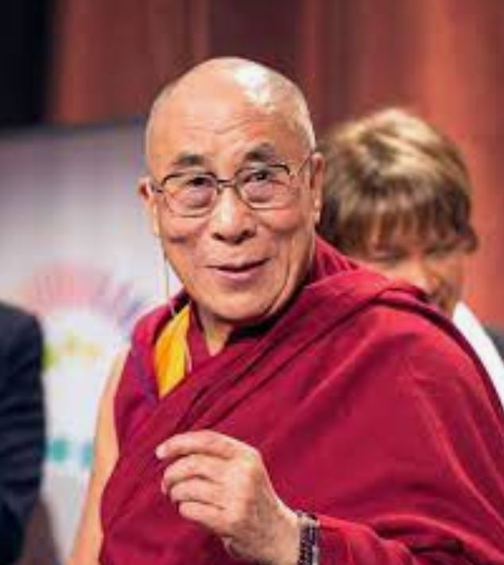

The 14th Dalai Lama, also called…Tenzin Gyatso, original name Lhamo Dhondup, (born July 6, 1935, Tibet), title of the Tibetan Buddhist monk who was the 14th Dalai Lama but the first to become a global figure, largely for his advocacy of Buddhism and of the rights of the people of Tibet. Despite his fame, he dispensed with much of the pomp surrounding his office, describing himself as a “simple Buddhist monk.. Source: Britannica ([link](https://www.britannica.com/biography/Dalai-Lama-14th)). Official biography ([link](https://www.dalailama.com/the-dalai-lama/biography-and-daily-life/brief-biography)).

|  |  |  |  |  |
| --- | --- | --- | --- | --- |
| **DL 1*. The Dalai Lama’s 2021 New Year Greeting*** | | | |  |
| […] the important thing is to think, to check if over the past year, you have used your time properly. That means check whether you have helped others, served others, and have at least not harmed them. That’s how to lead a meaningful life. If you only think selfishly and exploit other people, then you will not have spent your life properly. If you want to lead that kind of life, the New Year is a good time to begin. You should think, “The past is past. From today, in this new year, I may be physically the same, I may have the same name, but I will live my life in a more compassionate way, a more meaningful way.” […] because it’s New Year, you may hold a party and have a drink, and for a short while, you may feel happy. But if you drink too much, you start to fight, so then Happy New Year will be spoiled. So it would be better to celebrate a Happy New Year in a very peaceful, gentle way. And then like that not only at New Year, but throughout the whole year. | | | | |
| **Date** | 1/1/21 | **Source** | International Campaign for Tibet ([link](https://savetibet.org/dalai-lama-greets-new-year-urges-climate-action)) | |

|  |  |  |  |  |
| --- | --- | --- | --- | --- |
| **DL 2*. The Dalai Lama’s “Our Only Home” Video*** | | | |  |
| This Blue Planet is our only home. In the next one or two decades, I will go. There is some water on the moon also. But if we try to settle there, it is impossible. Mars, these stars, remain in the blue sky, it’s nice but to go (live) there is impossible. In India, vegetarianism has been practiced for over 1000 years, but in the west, people eat too much meat. It is not simply a question of love for these animals, but it is very bad for the ecology. Of course we Tibetans are also non-vegetarian but we decided (to be vegetarian). Most of our monastic institutions have now stopped serving meat. From a health viewpoint also vegetarianism is very suitable. If we make an effort we can change the world. Those who are still young can make a difference and shape a better future. The coming generation, they should think, the pleasant planet… blue planet is our only home. | | | | |
| **Date** | 3/1/21 | **Source** | International Campaign for Tibet ([link](https://savetibet.org/dalai-lama-greets-new-year-urges-climate-action)) | |

|  |  |  |  |  |
| --- | --- | --- | --- | --- |
| **DL 3*. The Dalai Lama’s letter to Greta Thunberg*** | | | |  |
| It is very encouraging to see how you have inspired other young people to join you in speaking out. You are waking people up to the scientific consensus and the urgency to act on it. I am also an ardent supporter of environmental protection. We humans are the only species with the power to destroy the earth as we know it. Yet, if we have the capacity to destroy the earth, so, too, do we have the capacity to protect it. It is encouraging to see how you have opened the eyes of the world to the urgency to protect our planet, our only home. At the same time, you have inspired so many young brothers and sisters to join this movement. | | | | |
| **Date** | 31/5/19 | **Source** | dalailama.com ([link](https://www.dalailama.com/news/2019/support-for-greta-thunbergs-speaking-out-about-the-climate-crisis)) | |

|  |  |  |  |  |
| --- | --- | --- | --- | --- |
| **DL 4*. A Conversation on the Crisis of Climate Feedback Loops*** | | | |  |
| Diana Chapman Walsh, moderator: Your Holiness, my first question to you is what inspired you to write that letter to Greta? Why did you want to be in touch with her? And how do you see this importance of her work now and going forward? This is your chance, we have brought you together, your Holiness.  Dalai Lama: It is really encouraging from a young community, a younger member of humanity, showing a genuine sense of concern of our future, of our planet. This is a very, very hopeful sign. Actually, you see, everybody wants a happy life. No question about that. Not only we human beings but also, you see, animals, insects. Everyone wants a happy life, and for that, you see, everyone is very much concerned about their own existence. The human brain is something very special, remarkable. Yet, judging our world, human beings are the biggest troublemakers. Other animals, it is their daily life to eat, sleep, have sex, but we human beings think about “us” and “them.” Human history, among the different species of the mammals on this planet, I think we human beings one way create a lot of good things but at the same time, we create a lot of problems. Today a lot of problems, even to some extent the ecology. Firstly, we think about ourselves; secondly, about our nation, our country; and finally, my family. So eventually, you see, we think in a very small circle. The reality of individual lives depends on the community or family. The family’s life depends on the community. Today’s world, you see, the entire seven billion human beings are one human community. So now the time has come to think about the entire humanity. In ancient times, there was a small circle of we, we that now, according to this reality, is a thinking of we. A small circle is now unrealistic. So seven billion human beings, you see, our entire life depends on each other.  […] Of course, basically, human nature is more self-centered, selfish from birth. But now, you see, an individual’s best interest depends on community. When we say community, the entire world is the same human community. So now they are taking care of themselves. In reality, on a practical level, we have to think about humanity, about the world. Not because of a religious matter but on a practical level. You see, our future depends on the entire humanity on this planet. So we have to think about this planet, it’s our home. And then, in ancient times, we said east, west, or north, or south, and within that, different religions, different colors, or different languages. Now these are minor issues. Now the time has come to think about humanity, oneness of seven billion human beings. We have to think about humanity. So it is important that we keep in our mind that an individual’s future depends on humanity. So we have to think about humanity, a happy humanity, a healthy world.  […] We already have solar power and wind power and we are putting them to use. Now we need more effort. We have to pay more attention to deforestation. We should think more seriously about the protection of this environment. Within my own lifetime, in Tibet, when I was young, you see, most of the mountains had a lot of snow, but gradually, year by year, less and less snowfall. There are some scientists who say because of global warming, Tibet will eventually become a desert. So this is such a serious matter. One of my commitments is to preserve the pattern of the ecology. Usually, you see, people don’t think much about the importance of preserving this environment. We should cultivate more trees. I think much depends on education. For a thousand years, we’ve behaved in this way, but because of a warmer climate, climate change, global warming, we now have to think seriously about the preservation of this ecology.  […] Our life over a thousand years, millions of years, you see, we take for granted this kind of life or this kind of a situation. We very much utilize natural resources. Due to that, there are some new sort of problems there. So I think we should now educate or those scientists should explain the reality, our lifestyle. Today our lifestyle is unchanging and also utilizes natural resources very much. We have to think seriously about the new situation and our way of thinking. Now we have to think about today’s reality. Through education and a young leader like you [Greta Thunberg] to raise awareness or seriousness through education about future generations. | | | | |
| **Date** | 10/1/21 | **Source** | dalailama.com ([link to transcript](https://www.dalailama.com/news/2021/a-conversation-on-the-crisis-of-climate-feedback-loops), [link to video](https://www.youtube.com/watch?v=reodvcdadKg)) | |

Collected by Daniela Ribitsch