**INSPIRATIONBASE**

*A collection of ethical leadership speeches*

Xiye Bastida

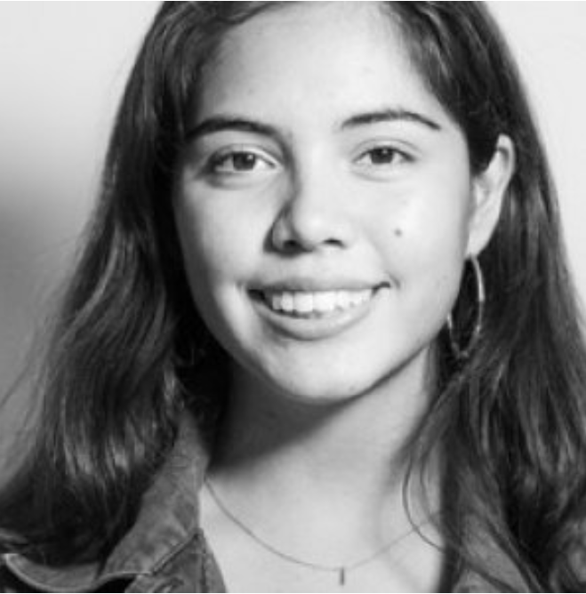

Xiye Bastida is a teenage climate activist based in New York City and one of the lead organizers of the Fridays For Future youth climate strike movement. For the first climate strike in March, 2019, she mobilized 600 students from her school and has taken a citywide leadership role in organizing climate strikes and speaking out about climate justice issues in rallies and town halls. Bastida was born and raised in Mexico as part of the Otomi-Toltec indigenous peoples. She sits on the administration committee of the Peoples Climate Movement, where she brings the voice of youth to existing grassroots and climate organizations. Bastida launched a youth activism training program to expand the climate justice movement and is a member of Sunrise Movement and Extinction Rebellion. In 2018, she was invited to the 9th United Nations World Urban Forum to speak about indigenous cosmology. She received the “Spirit of the UN” award in 2018. Source Omega ([link](https://www.eomega.org/workshops/teachers/xiye-bastida))

|  |  |  |  |  |
| --- | --- | --- | --- | --- |
| **XB 1*. How Are Young People Making The Choice To Fight Climate Change?*** | | | |  |
| My name is Xiye Bastida, and I am a 17-year-old climate justice activist. I know that a lot of people look at me in the hallways and say, like, oh, the climate girl or whatever. But what I'm seeing is that we inspire others through action and through example because there is no hope without action…  I love having friends who are climate activists because then we can share our feelings with each other. For example, I told my friends the other day I was, the first time in seven months, at the beach. And I was just sitting there hearing the ocean and thinking, for the first time ever, actually thinking, my kids are never going to be on the beach because we're going to have flooding, and the ocean is going to come up all the way to the streets. But beaches take thousands of years to form. So that was the first time which I thought, are my kids ever going to see a beach or be on an island? And these are the type of things that I can share with my friends. And they will say, this is why we have to kick ass harder (laughter). You know, this is why we have to share how we feel. Because stories touch people, and data doesn't…  My mom would take out the food that we brought. And I would particularly remember her taking out tortillas. And so the prayer would begin. Thank you to Mother Earth for gifting us with air, water and the places for our food to grow. Thank you to the hands who planted the seeds. Thank you to the hands who harvested the corn. Thank you to the hands who made the tortillas and for the transportation that it took for all of us to come together and share this beautiful moment. That is how I grew up, with a mindset that we have to thank everything. We have to thank the Earth because it gives us everything we need to live. It gives us shelter, food, and all that it asks is that we protect. And to grow up with that love for the Earth. That reciprocity and that reciprocal love and understanding was just how my whole world was depicted to me. And when you grow up, you think that everybody thinks the same way that you do. And when you understand that people don't, that's when your bubble gets popped…  I also remember when I was driving by el Rio Lerma. It's the most polluted river in Mexico. And it's right by my hometown. I was driving by it with my dad. And we had to drive with the windows up because the smell would be so bad due to the toxins. And he told me, you know, I used to be able to bathe in this river when I was your age. In one generation, the river went from being a source of life beauty and culture to being one of the most neglected places in our community. How does that happen?..  I love the saying that says we don't inherit the land from our ancestors. We borrow it from our children. If we have that thinking every time, then I am thinking right now I'm going to take care of this Earth for my children. And then my children are going to think the same. And it's this very basic notion of you leave the place in which you are better than how you found it. | | | | |
| **Date** | 22/05/2020 | **Source** | NPR ([link](https://www.npr.org/transcripts/860168455)) | |

|  |  |  |  |  |
| --- | --- | --- | --- | --- |
| **XB 2*. “Young People Have Had Enough”*** | | | |  |
| So, my story goes way back. And I would say a lot of climate activists today didn’t know we were climate activists until someone else called us that. I think that, personally, I’ve always cared about the environment, and I’ve always done my best, but it wasn’t labeled until recently. And for me, it was the power that I thought an individual voice had, which was inspired by Greta Thunberg’s message. And I also suffered the climate crisis myself. So, when I was 13 years old in Mexico, in my town, my town suffered from heavy rainfall, and that also caused our river there to overflow, which had heavy contamination because of the factories that are near there. And so, that was the first time that I saw the climate crisis firsthand. And it didn’t really hit me that this was such a global issue until I came to New York City and I saw the effects that Hurricane Sandy had had on Long Island. And that was the moment where I realized that the climate crisis not only can follow you everywhere but is happening everywhere and affecting low-income communities and communities of color the most….  For indigenous people, taking care of the Earth is not a movement. It’s a culture. And that’s what I want to see out of these strikes and out of our pressure. This shouldn’t be a movement. This shouldn’t be something that has momentum. It should be something that we live with every day. And so, indigenous peoples’ cosmology is that you take care of the Earth because the Earth takes care of you. And you need reciprocity. You need to give back. And right now I’m seeing a lot of indigenous voices being lifted up, including in today’s global strike. And we’re saying all that knowledge of taking care of the Earth for thousands of years is so important, because the environmental movement didn’t start 60 years ago. It’s always been here… | | | | |
| **Date** | 20/09/2019 | **Source** | Independent Global News ([link](https://www.democracynow.org/2019/9/20/global_climate_strike_new_york_minnesota)) | |

|  |  |  |  |  |
| --- | --- | --- | --- | --- |
| **XB 3*. Meet the young activists of color who are leading the charge against climate disaster*** | | | |  |
| Indigenous knowledge and cosmology: We don’t call water a resource; we call it a sacred element. The relationship we have with everything that Earth offers, it’s about reciprocity. That’s the only way we are going to learn how to shift our culture from an extraction culture to a balanced and harmonious culture with the land. The first ones to be affected are Indigenous communities who are displaced because of infrastructure and disrespect of the land. It’s not just coming from Black, Brown, and Indigenous communities being victims of pollution that the fossil fuel industry brings. It’s much deeper than that. Whose spaces are they choosing to contaminate and build infrastructure in the first place? | | | | |
| **Date** | 11/11/2019 | **Source** | VOX ([link](https://www.vox.com/identities/2019/10/11/20904791/young-climate-activists-of-color)) | |

|  |  |  |  |  |
| --- | --- | --- | --- | --- |
| **XB 4*. If you adults won’t save the world, we will* (TED talk)** | | | |  |
| [Letter to her grandmother]  Dear Abuelita, I know I haven't been home for a while. You are in our lovely home in Mexico, and I'm here in the US, fighting for our future. You're probably watering the roses, taking care of the peaches and making sure your turtles are well-fed. That's one of the things I miss the most about home -- spending time with the flowers while you tell me stories about your childhood. As you know, we have been living in New York City since 2015. But life has completely changed over the past year. At first, New York City was about museums and parks and school and friends. Now it serves as a web that connects me with all the other people who are organizing to save the planet. You know how it started for me? It was Dad and his wisdom. Everything you taught him, he went and taught the world. All of his words about the responsibility that we have as humans to live in balance with nature were passed down to me. I noticed the universal disconnect to our planet and remembered what you once told me: "Leave everything better than you found it." I know you were talking about the dishes, but of course, that applies to the planet as well. I didn't know what to do at first. The world is so big, and it has so many bad habits. I didn't know how a 15-year-old was supposed to change anything, but I had to try. To put this philosophy into practice, I joined the environmental club at my high school. However, I noticed that my classmates were talking about recycling and watching movies about the ocean. It was a view of environmentalism that was so catered towards an ineffective way of climate activism, one that blames the consumer for the climate crisis and preaches that temperatures are going up because we forgot to bring a reusable bag to the store. You taught me that taking care of Mother Earth is about every decision that we make as a collective. I am happy to tell you, Abuelita, that I changed everybody's mind in that club. Instead of talking about recycling, we started to write letters to our politicians to ban soft plastic altogether. And then, the unexpected happened: we started striking from school. I know you've probably seen it on the news, and maybe it's not that special anymore. But at the time, it was a huge deal, Abuelita. Imagine kids not going to school, because we want people to save the world. For the first global climate strike, which was called on by Greta Thunberg, I got 600 of my classmates to walk out with me. Greta Thunberg is a teenager who first started striking for climate. Her boldness inspired me, and I was shocked by the realization that youth could turn public opinion on social issues. The movement exploded. And I became one of the main organizers for New York, the US and the world. I started speaking up about climate justice and Indigenous rights and intergenerational cooperation. That was only the beginning, though. The busiest week of my life will forever be the week of September 20, 2019. Me and my friends got 300,000 people to strike for climate in New York. I wish you could have been there. We walked through Wall Street, demanding climate justice. That same month, I went to the United Nations Climate Summit. I spoke on a panel with Al Gore. I met Jay Inslee and Naomi Klein and Bill McKibben and the president of the United Nations. It was the most amazing week of my life, because everyone I knew came together -- all my teachers, all my classmates ... And even some of my favorite stores closed down to strike for climate. If you had asked me why I did all of that, my only answer would be, "How could I not?" It's been one year since it all started for me, and it gets a little tiring at times. But if there is one thing that you taught me, it's resilience. I remember that you went to Mexico City every day for 30 years to get money for the family. And I know that Abuelito has been going out for 20 years to protect sacred land from big companies that want to take it. A year is nothing compared to the struggles that our family has been through. And if our struggles make the world a better place, they will make us better people. There have been some hardships, Abuelita. Out there in the world, people expect us kids to know everything, or at least they want us to. They ask questions and I give answers, as if I really knew how the world works. They want hope, and we give it. I have organized, written, spoken and read about climate and policy almost every day for the past year. And I'm just a little worried that I won't be able to do enough, Abuelita. For me, being 18 years old and trying to save the world means being a climate activist. Before, maybe it meant studying to be a doctor or a politician or a researcher. But I can't wait to grow up and become one of those things. The planet is suffering, and we don't have the luxury of time anymore. Saving the world as a teenager means being good with words, understanding the science behind the climate crisis, bringing a unique perspective into the issue to stand out and forgetting about almost everything else. But sometimes, I want to care about other things again. I want to be able to sing and dance and do gymnastics. I truly feel that if all of us took care of the Earth as a practice, as a culture, none of us would have to be full-time climate activists. When businesses turn sustainable, when the power grid runs on renewable energy, when the school curriculum teaches us that taking care of the Earth is part of our humanity, maybe I can do gymnastics once again. Don't you think so, Abuelita? We can do this. All I'm trying to do with my work is give that optimistic mindset to other people. But it's been a little hard. There is greed, there's pride, there's money, and there's materialism. People make it so easy for me to talk to them, but they make it so hard for me to teach them. I want them to have the confidence to always do their best. I want them to have the heart and the courage to love the world, just like you taught me. I wrote this letter to thank you. Thank you for inviting me to love the world since the moment I was born. Thank you for laughing at everything. Thank you for teaching me that hope and optimism are the most powerful tools we have to tackle any problem. I do this work because you showed me that resilience, love and knowledge are enough to make a difference. I want to go back to Mexico and visit you. I want to show you the pictures of the things that I have done. I want to show you the climate legislation that we've been able to pass. I want to smell the flowers and fight for climate justice alongside you. | | | | |
| **Date** | 07/2020 | **Source** | TED ([link](https://www.ted.com/talks/xiye_bastida_if_you_adults_won_t_save_the_world_we_will?language=en)) | |